File Permissions
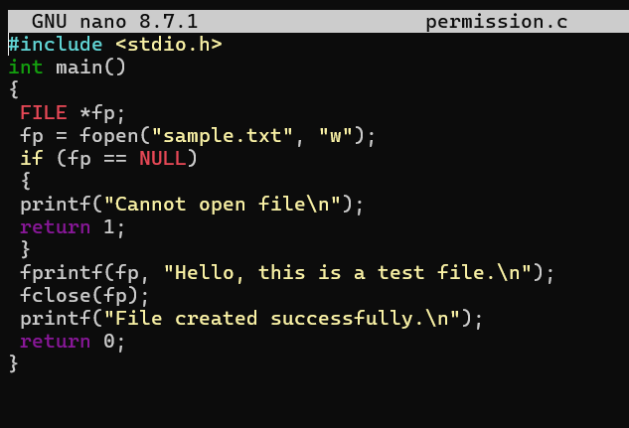
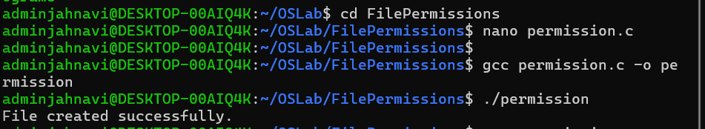
1)Give Read and Write only to the owner
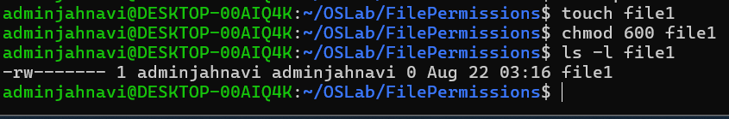
2) Give Read and Write to the owner and group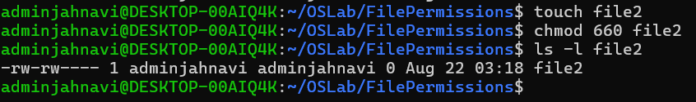
3) Only owner can read and write 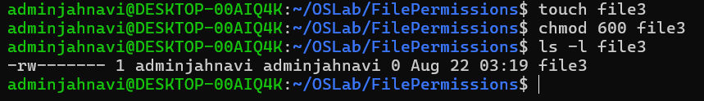
4) Owner read/write, everyone else read-only 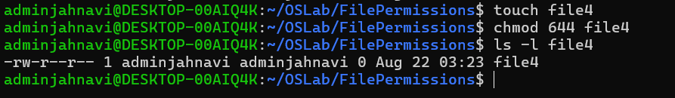
5) Owner can do everything, others can only read and execute 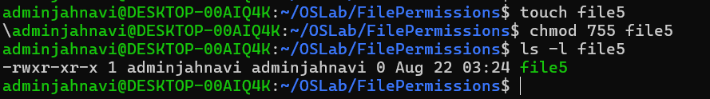
6) Owner and group can read/write 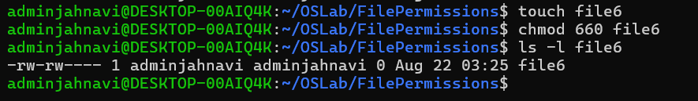
7) Only owner can execute 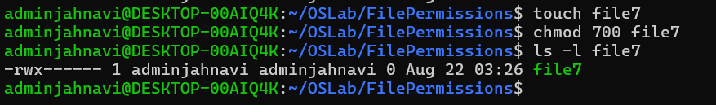

8) Owner: read + write; Group: nothing; Others: nothing → chmod 600
9) Owner: read + write; Group: read; Others: read →chmod 644
10) Owner: read + write + execute; Group: read + execute; Others: read + execute → chmod 755
11) Owner: read + write; Group: read + write; Others: nothing → chmod 660
12) Everyone: read only → chmod 444

